**GARAGE MANAGEMENT SYSTEM**

**College Name**: TIRUPPUR KUMARAN COLLEGE FOR WOMEN

**College Code**: ASBRU3J

**TEAM ID**: **NM2025TMID28348**

**TEAM MEMBERS: 4**

**Team Leader Name: HELAN PRINCY.S**

**Email: selvakumar805155@gmail.com**

**Team Member1: HARSHINI.B**

**Email: balamurugansuppu58@gmail.com**

**Team Member: INDIRAA.S**

**Email: sindiraa09@gmail.com**

**Team Member: JASMIN.S**

**Email: itbring99@gmail.com**

**1.INTRODUCTION**

**1.1 Project Overview**

The **Garage Management System (GMS)** is a software application designed to automate and manage the day-to-day operations of an automobile service center or garage. The system provides a centralized platform for handling customer details, vehicle information, service history, mechanic assignments, spare parts inventory, billing, and reporting.

By replacing traditional manual processes with a digital system, the GMS helps garage owners and staff improve service delivery, reduce errors, and enhance customer satisfaction. The system can be developed as a web or desktop application, depending on the environment and user requirements.

**1.2 Purpose**

The primary purpose of the Garage Management System is to:

* Simplify and automate garage operations
* Maintain accurate records of customers and their vehicles
* Schedule and manage service appointments efficiently
* Track inventory of spare parts and supplies
* Generate accurate invoices and financial reports
* Enhance overall productivity and customer experience

This system is intended to reduce manual work, minimize paperwork, improve data accessibility, and support decision-making through real-time information and reports.

**DEVELOPMENT PHASE**

**Creating Developer Account:**

By using this URL - <https://developer.salesforce.com/signup>

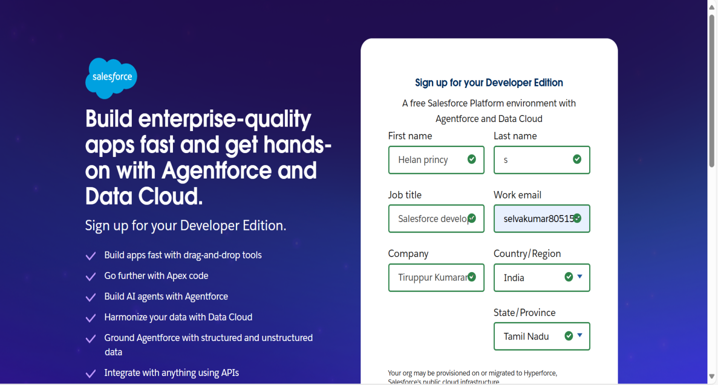

**Create a objects:** Appointment, Billing details and feedback, Customer details, Service records.

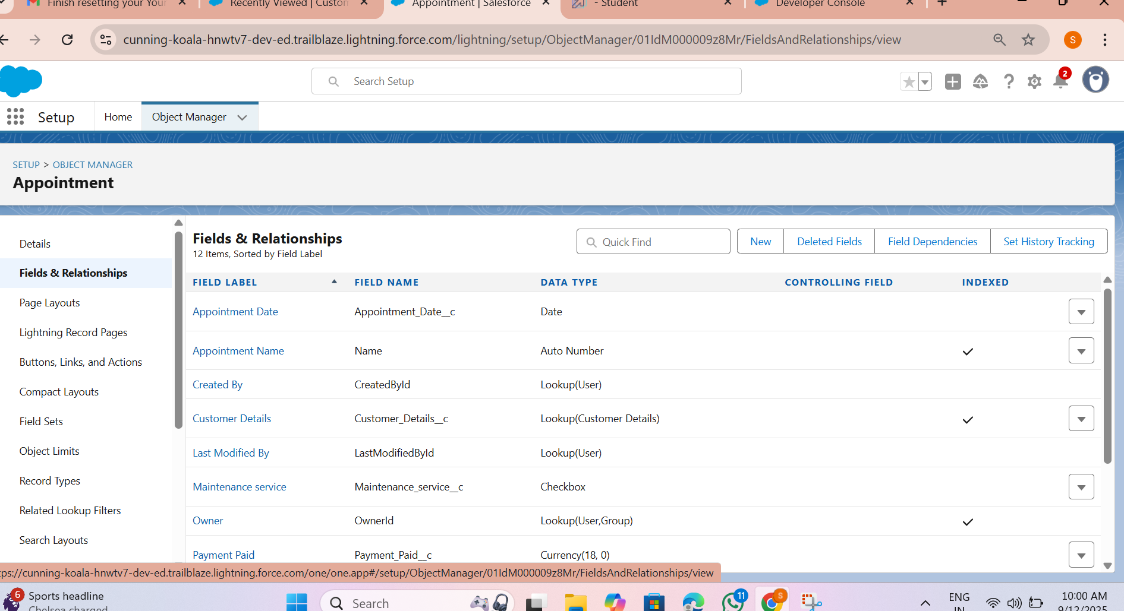

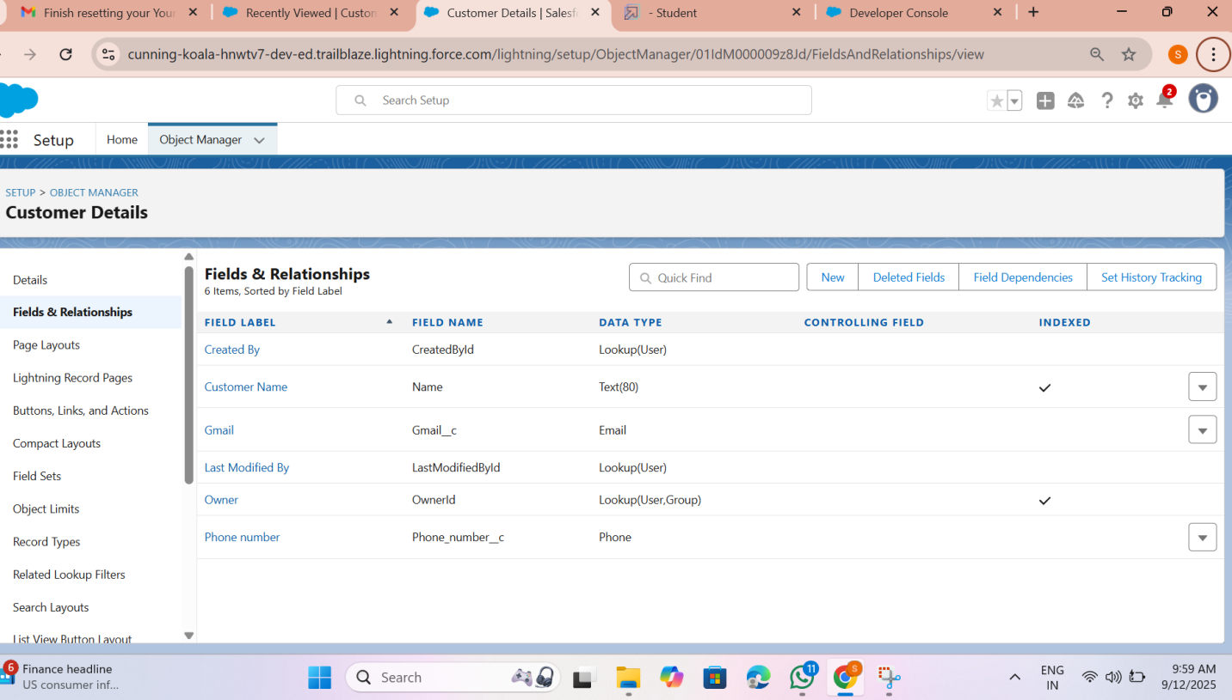

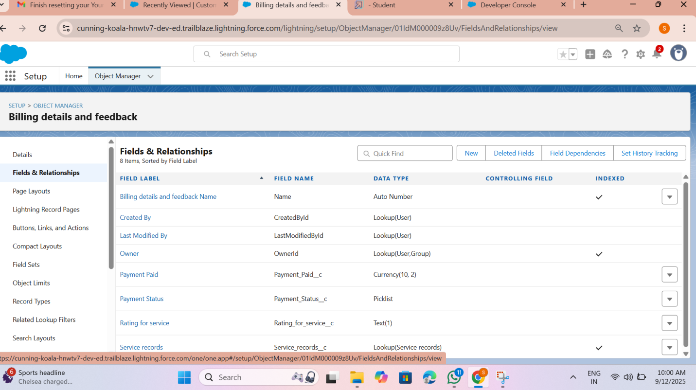

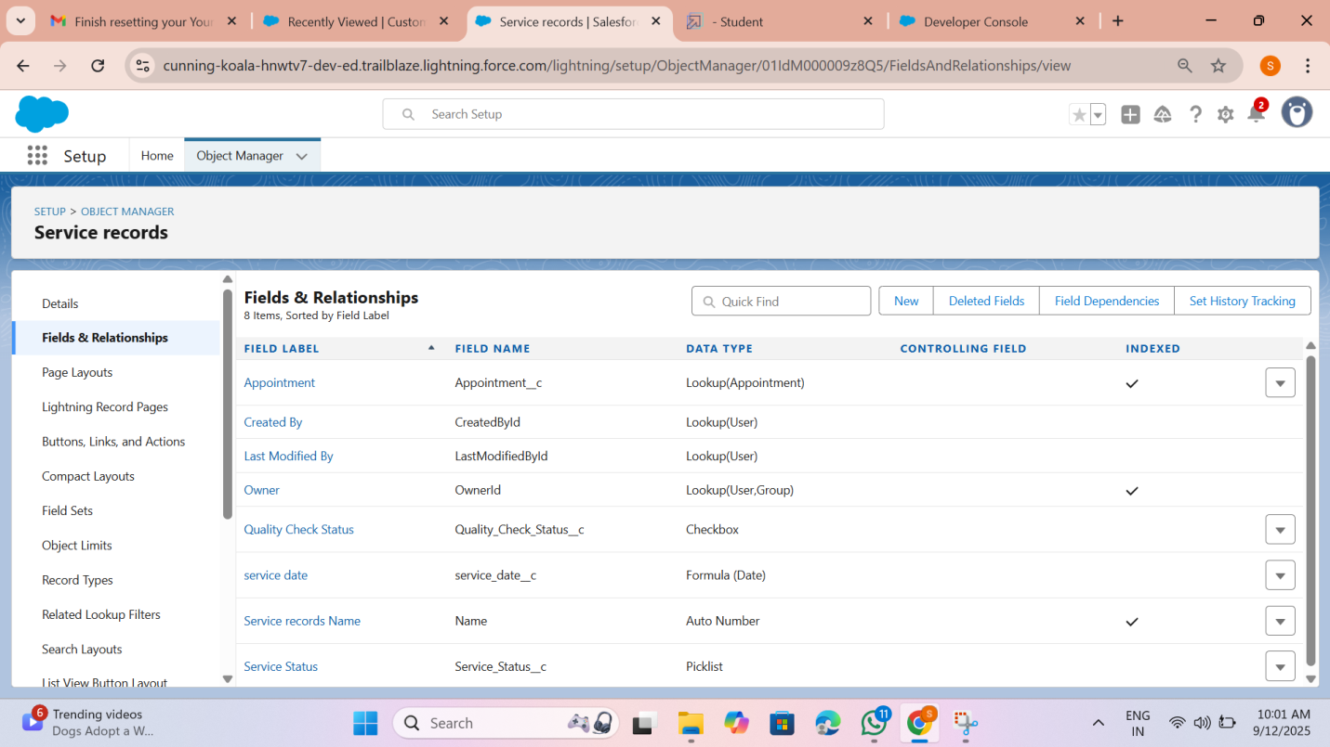

● Developed Lightning App with relevant tabs

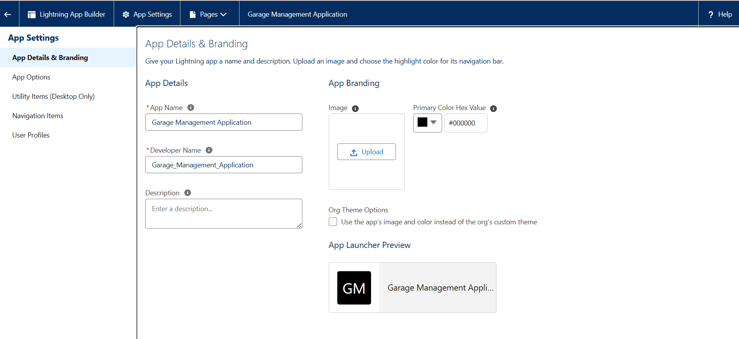

● **To create a validation rule to a Garage Object**

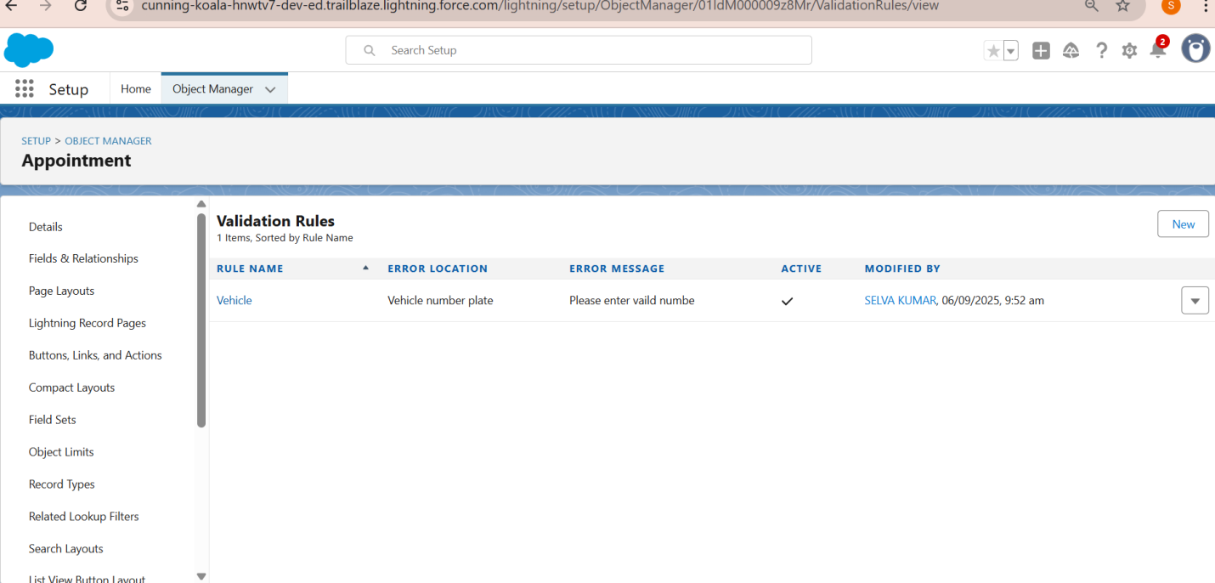

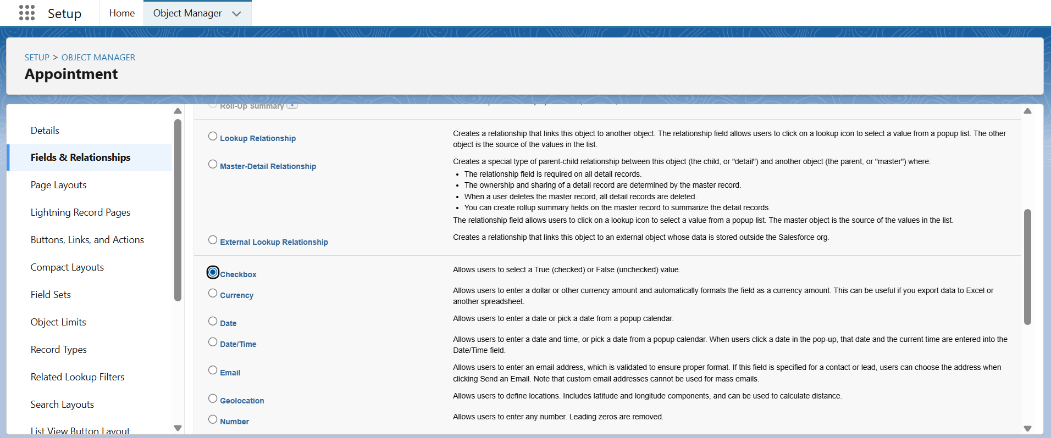

● Implemented Flows for monthly rent and payment success

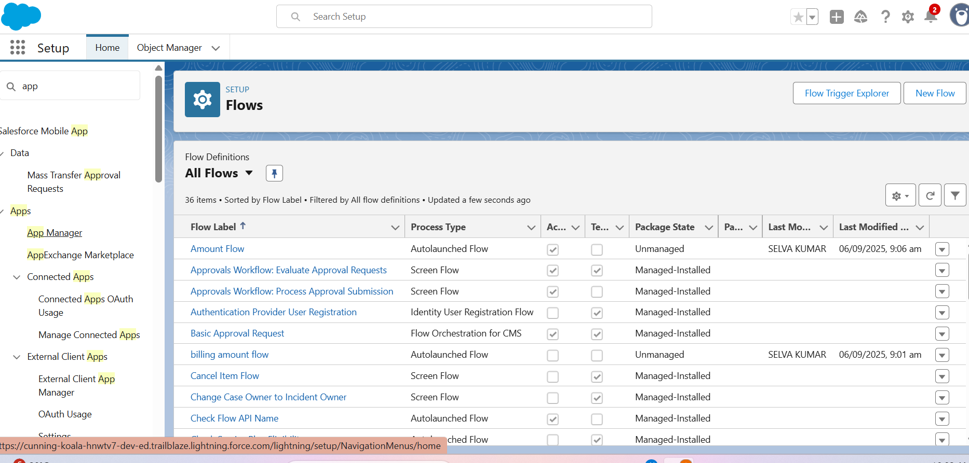

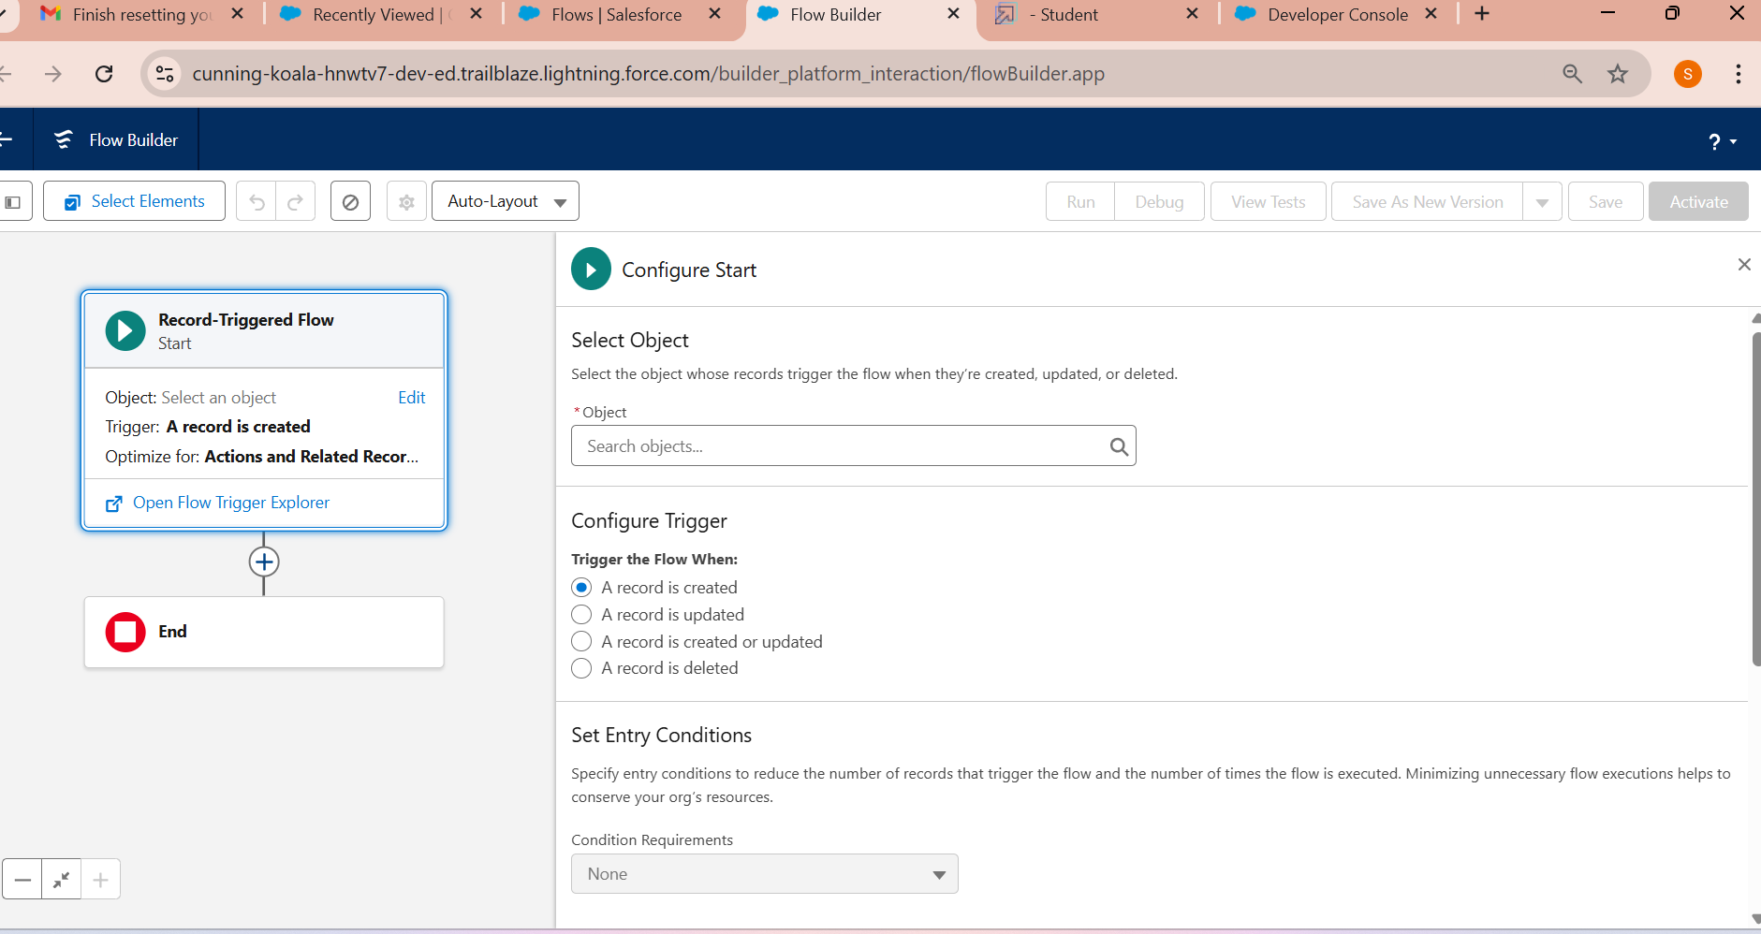

● Added Apex trigger to restrict multiple tenants per property

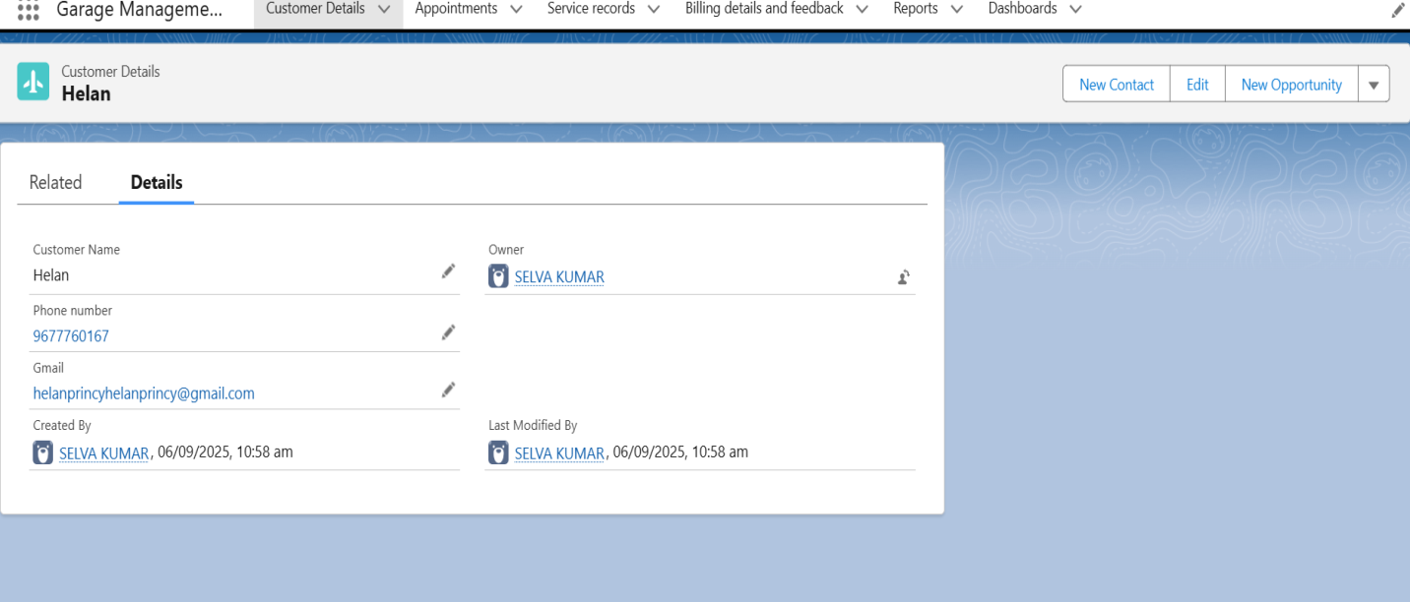

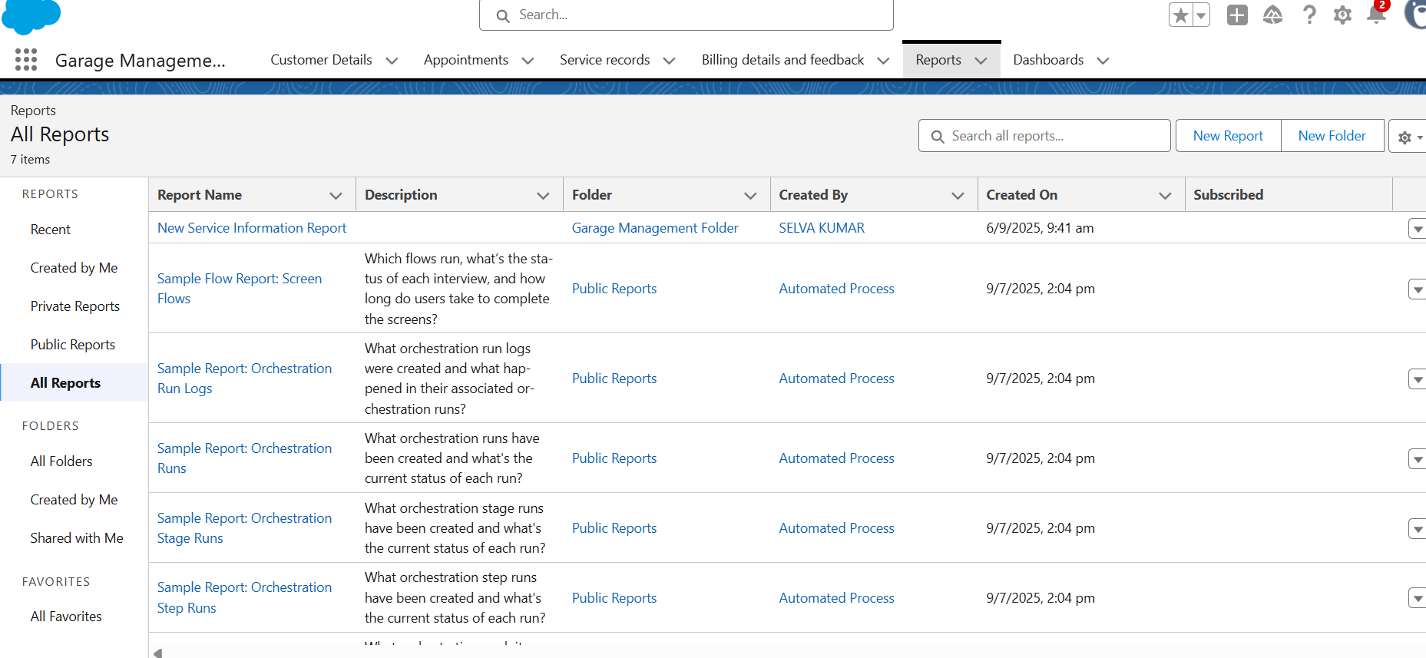

● Scheduled monthly reminder emails using Apex class

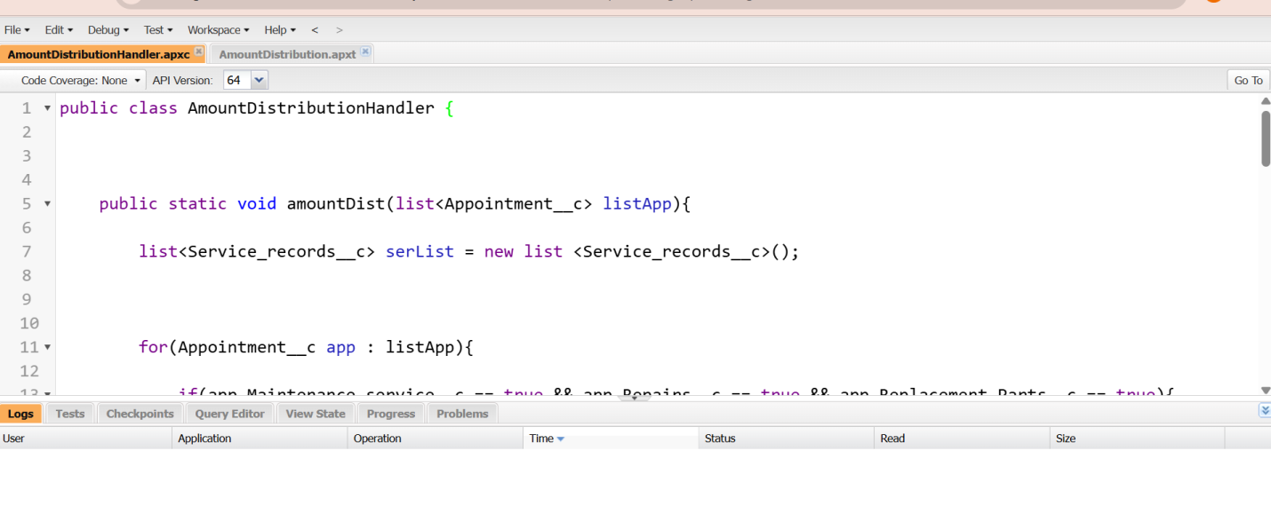

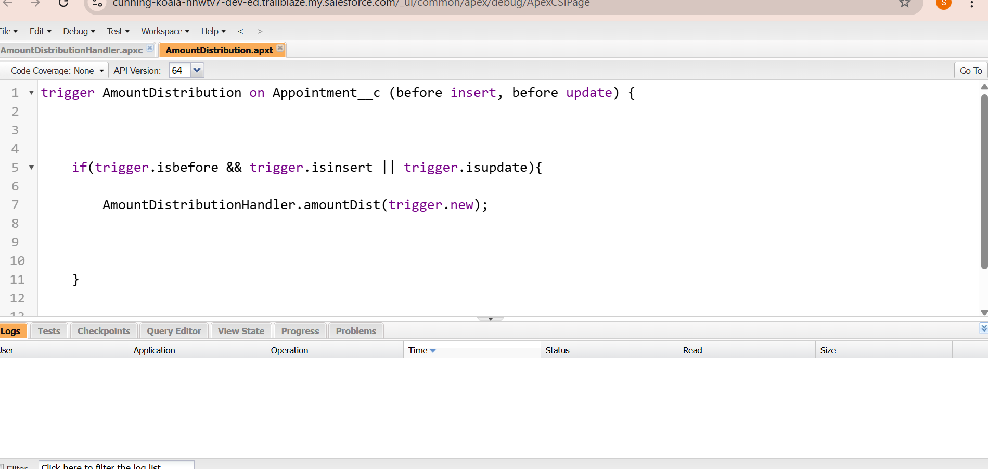

* Built and tested email templates for leave request, approval, rejection, payment, and reminders



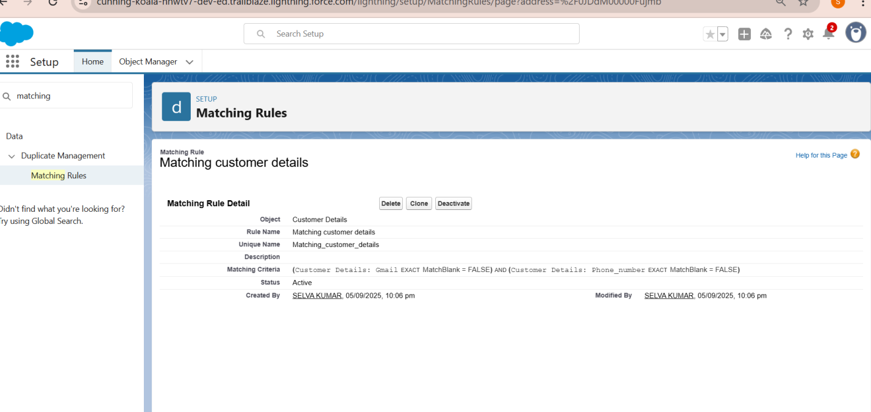

● Apex Trigger Create an Apex Trigger



● FLOWS

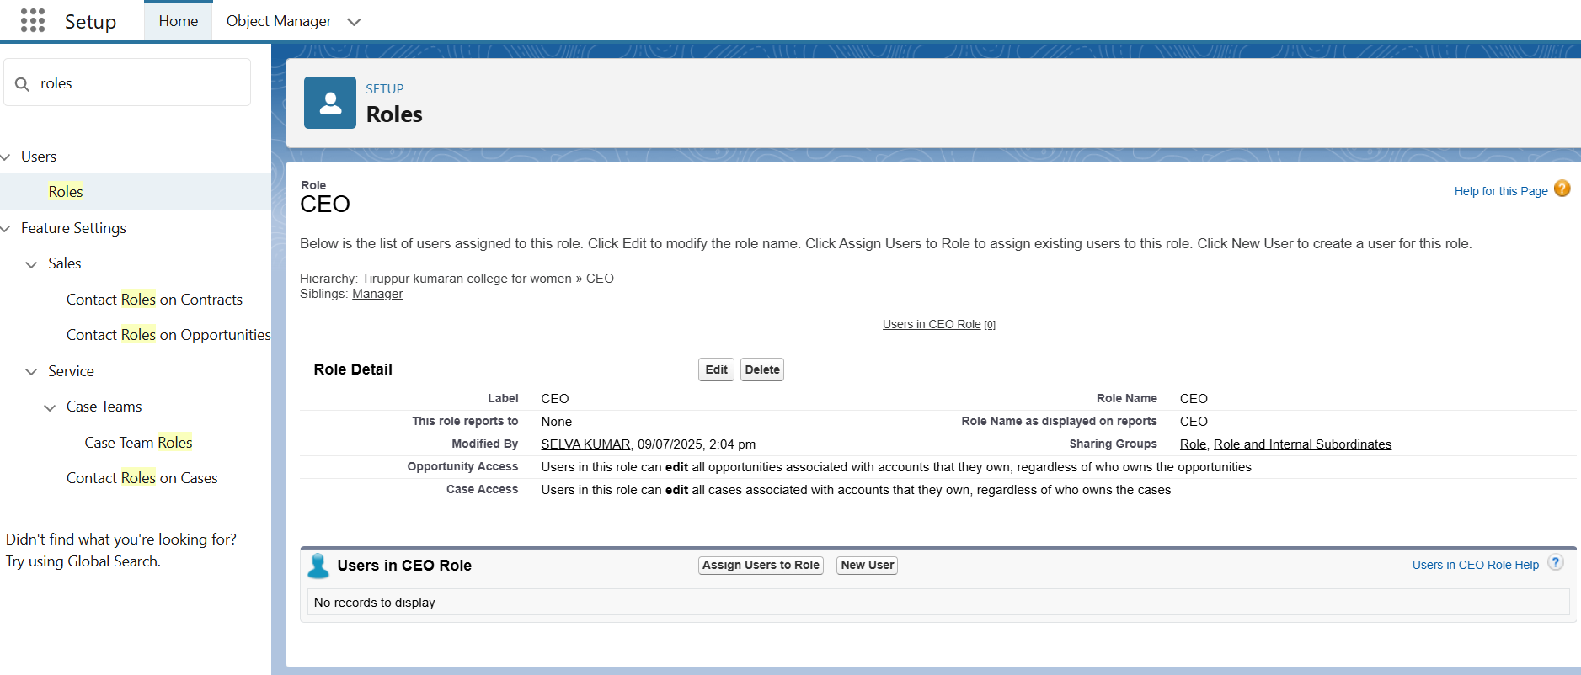

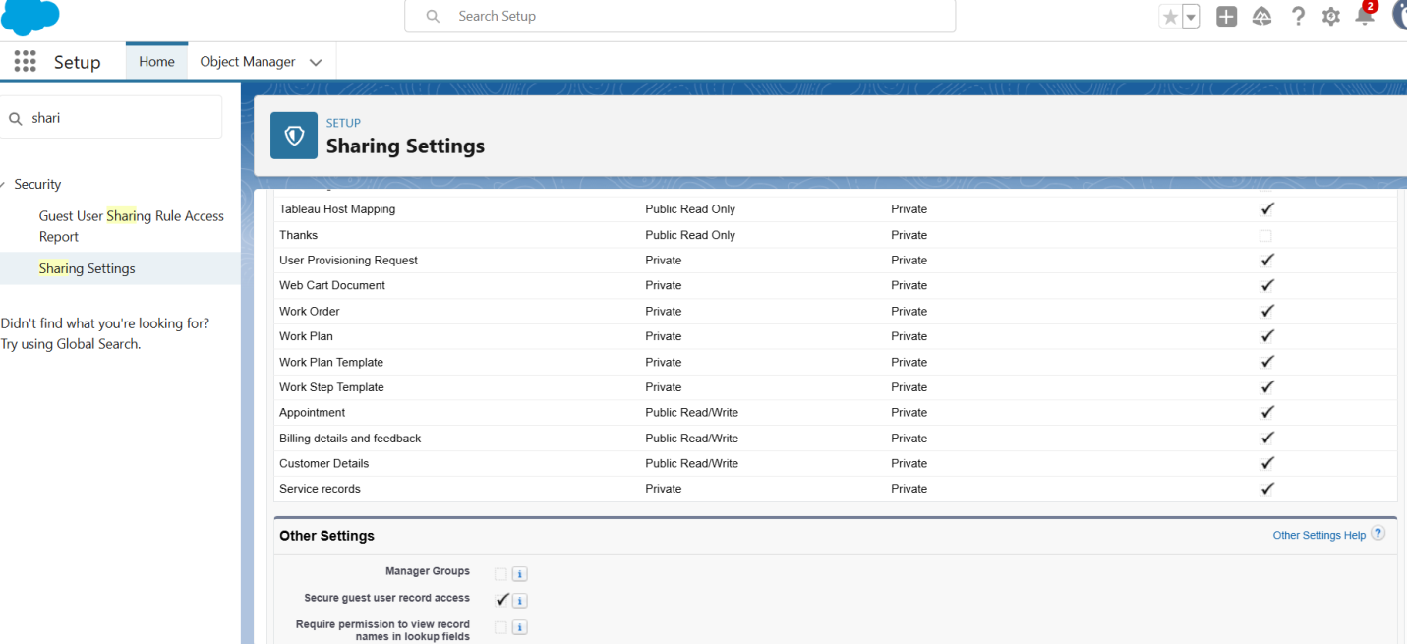

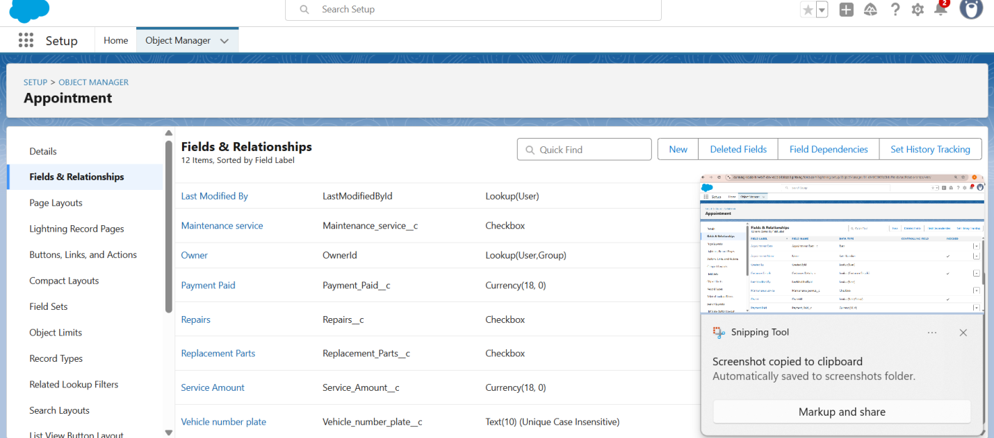



**FUNCTIONAL AND PERFORMANCE TESTING**

Performance Testing

* Trigger validation by entering duplicate tenant-property records

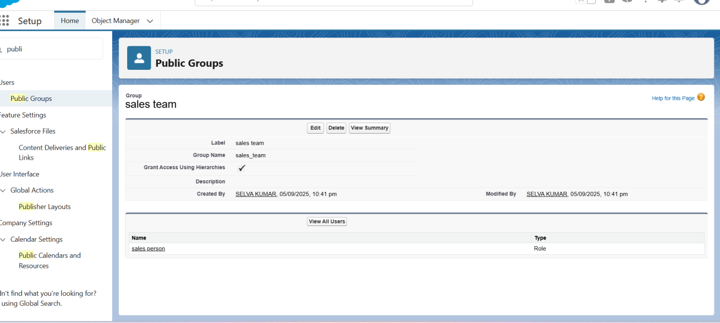

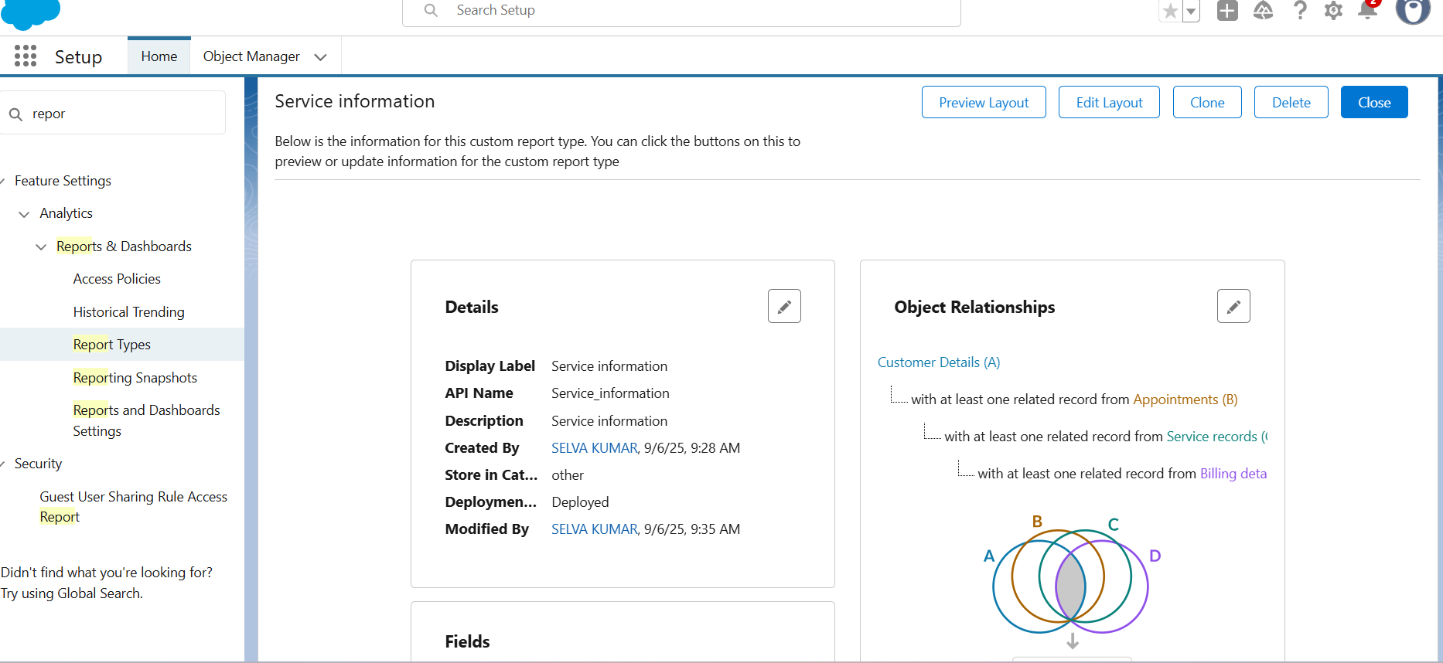



● Test flows on payment update





**RESULTS**

**Output Screenshots**

● Tabs for Property, Tenant, Lease, Payment







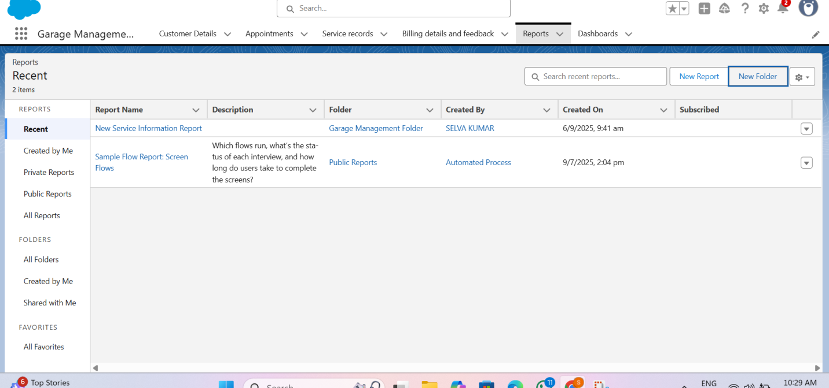







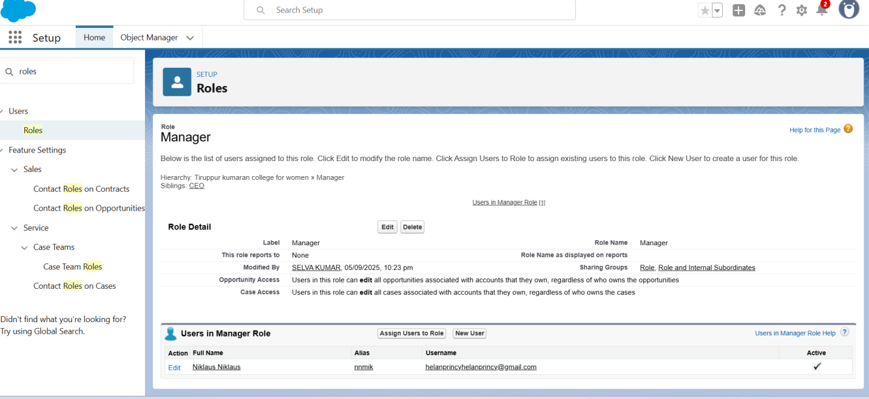

CONCLUSION

The Garage Management System is a vital tool for modernizing and improving the operational efficiency of auto repair shops. By automating routine tasks and centralizing information, the system reduces errors, saves time, and provides better service to customers. The development phase plays a crucial role in shaping a successful, fully functional system that meets user expectations and adapts to future needs. With proper planning, execution, and maintenance, the GMS can significantly enhance both the management and customer experience within a garage environment.

APPENDIX

Apex handler

public class AmountDistributionHandler {

    public static void amountDist(list<Appointment__c> listApp){

        list<Service_records__c> serList = new list <Service_records__c>();

        for(Appointment__c app : listApp){

            if(app.Maintenance_service__c == true && app.Repairs__c == true && app.Replacement_Parts__c == true){

                app.Service_Amount__c = 10000;

            }

            else if(app.Maintenance_service__c == true && app.Repairs__c == true){

                app.Service_Amount__c = 5000;

            }

            else if(app.Maintenance_service__c == true && app.Replacement_Parts__c == true){

                app.Service_Amount__c = 8000;

            }

            else if(app.Repairs__c == true && app.Replacement_Parts__c == true){

                app.Service_Amount__c = 7000;

            }

            else if(app.Maintenance_service__c == true){

                app.Service_Amount__c = 2000;

            }

            else if(app.Repairs__c == true){

                app.Service_Amount__c = 3000;

            }

            else if(app.Replacement_Parts__c == true){

                app.Service_Amount__c = 5000;

            }

    }

    }

}

**Trigger Handler**

trigger AmountDistribution on Appointment__c (before insert, before update) {

    if(trigger.isbefore && trigger.isinsert || trigger.isupdate){

        AmountDistributionHandler.amountDist(trigger.new);

    }

}